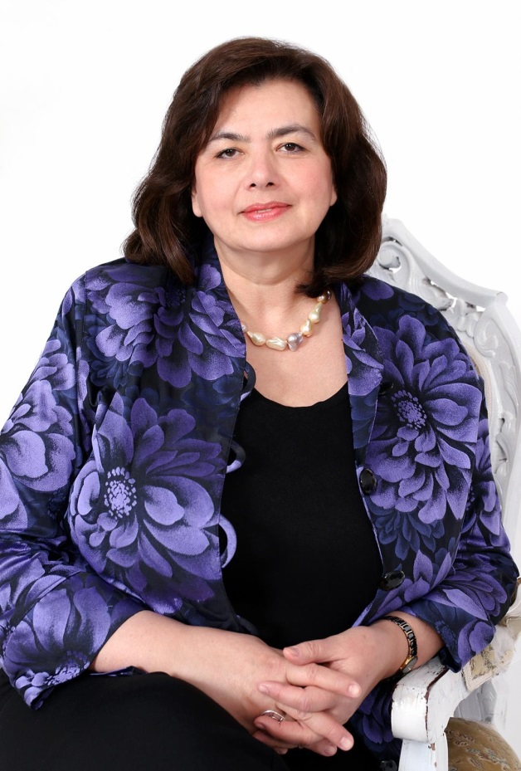

Dr Nata Menabde

Candidate for WHO Regional Director
for Europe

EQUITY
INNOVATION
IMPACT

www.NataMenabde4RD.com

Message from Dr Nata Menabde

With this message, I seek your support for my candidacy for Regional Director of the European Office of the World Health Organization (WHO).
Good health is a precondition, indicator and outcome of sustainable development and human wellbeing; it is also a driver of Europe’s social and regional harmony. While great advancements in health have been made in the WHO European Region, progress has been uneven across countries and we must scale up our efforts to achieve all of the ambitious goals and targets set out in the 2030 Agenda for Sustainable Development.
However, the road ahead is a rocky one. The health status of populations and the strength of national health systems vary greatly across the Region and the daunting challenge of achieving Universal Health Coverage in each country often looms in a sharp contrast with the finite available resources.
The underlying principles guiding my philosophy and conviction are EQUITY – in line with the Sustainable Development Goals agenda of leaving no one behind; INNOVATION – exploring advancements such as digital health technologies to improve access, reduce costs, enhance system efficiency, and ultimately reduce inequalities in health; and IMPACT – maximum results for the maximum number: making a visible and demonstrable difference to the lives of the citizens, especially the vulnerable, the under-served and unreached.
WHO has a critical role in making this possible. Therefore, the position of Regional Director is of vital importance. S/he must have a deep understanding of the values, diversity and uniqueness of each and every European country, regional and global health scenario. When I served Europe during four years as the WHO Deputy Regional Director, I witnessed first-hand the many complex roles the Regional Director must embrace in the Region, and at the global level, as a member of WHO’s global corporate leadership team.
As a Georgian national with extensive and diverse experiences in countries, regions and at the global level, I have an in-depth understanding of the regional and global health context of the social, political, environmental, cultural, economic and ethnic issues that affect the European Region. If elected, I shall ensure that we move – Member States and Secretariat – as One WHO, firmly and with agility, from vision to action and achieve greater impact on the health of all Europeans, in alignment with the Tallinn charter. I shall serve and be guided by the Member States, and will guarantee a gender sensitive, safe and enabling environment for the Regional Office so that staff can work to a consistently high standard.
I am committed to serve and communicate to widely different target groups, including politicians, policy makers, social networks, civil society, academia, and media. My attention and care will be centred towards WHO’s greatest asset, its staff. As Regional Director, I will visit, listen, engage and continue to learn from the wealth of knowledge and excellence within the Region. I will support each Member State in a tailored and adaptable manner for a faster and sustainable transition toward greater social equity in the Region. My focus on measuring effectiveness and efficiency will be relentless to guarantee progress.
If trusted with the honour to serve as the Regional Director, I commit through my vision and the programme, for a more efficient and effective WHO’s service to its European Member States with the vision of health and well-being for all in Europe.

Nata Menabde

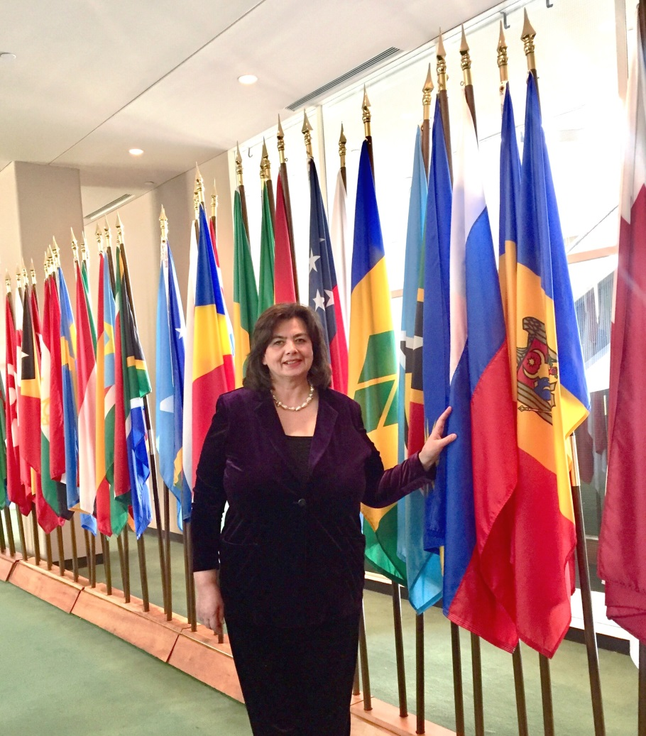
A Vision for Health in Europe
Dr Menabde’s approach is rooted in the mutually reinforcing and closely aligned UN Sustainable Development Goals, the WHO's 13th General Programme of Work (GPW13) and Health 2020. Going beyond business as usual and championing innovation is the way forward. The focus is on three inter-connected priorities to achieve her vision of a strong WHO Europe. The guiding principles are EQUITY – leaving no one behind; INNOVATION – championing new way of doing things; and IMPACT – reaching the greatest number for maximum results.

Equity and Innovation for Impact
– SDG 2030 and beyond
Health as a driving force for achieving regional
and global goals

Standing for Equity above all – leaving no one behind
A speedier transition toward greater social equity in the Region requires bold and strategic political leadership, engagement of all stakeholders and a whole-of-society approach. The WHO European Region, along with partners will step up as regional and global leader to:
  - Champion the case of Universal Health Coverage (UHC) through mobilizing collective action for investing in health, aligned with the WHO Investment Case;
  - Produce evidence-informed monitoring and evaluation of progress toward UHC and achievement of SDG3 and beyond;
  - Drive the health system agenda – by fully implementing the Tallinn Charter; Health Systems for Prosperity and Solidarity and leave no one behind;
  - Tackle the social determinants of health with a special focus on employment, age, gender and on highest vulnerabilities;
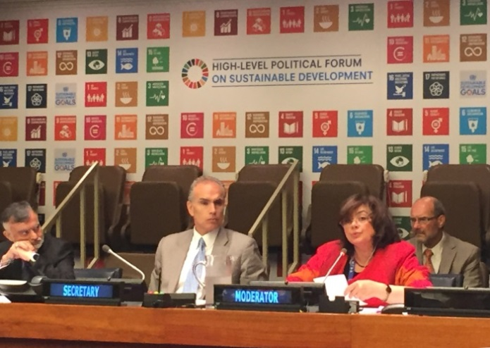
  - Trigger a concerted regional effort to re-invent primary health care, patient safety, access to essential services and affordable and effective medicines and vaccines, improve quality of care and instil better health performance as a whole; and
  - Advocate for greater public and private sectors support to research, development and the promotion of vaccines and medicines, and accelerate their availability and use.

Enhancing health security
From epidemics to migrations, natural and man-made disasters, various humanitarian and economic crises affect the health and well-being of the population, and influence political and economic stability in the Region. Conversely, the attainment of health contributes to peace and security. Dr Menabde’s vision envisages WHO European Region as global leader that anticipates and shapes the public health agenda, in order to:
  - Promote an inclusive One Health approach to tackle communicable diseases threats, in particular antimicrobial resistance (AMR) and more specifically antibiotic resistance by fostering research, optimizing the use and access to antimicrobial medicines, investing in new technologies, strengthening surveillance, and preventing infections;
  - Boost the full implementation of International Health Regulations 2005 in all European countries;
  - Lead on specific public health goals agreed with Member States, such as measles and rubella elimination and intensified fight against AIDS and multidrug-resistant tuberculosis;
  - Facilitate the coordination of national and international responses to the growing health challenges stemming from migration, in countries of transit or destination, including cross-border health care strategies; and
  - Scale-up country guidance for the use of innovation technologies to modernize health infrastructure and increase health systems resilience to address outbreaks as well as the detrimental effects of conflicts and violence.

Delivering health gains across the life-course
The European Region carries the highest burden of noncommunicable diseases (NCDs), including mental health disorders as a leading public health challenge. Supporting the Member States, WHO Europe will:

The way forward towards 2030 and beyond requires
- Embracing a reformed, coherent and more strategic UN Development System and a new results-focused and agile way of collaborating with a wide range of partners, including civil society and the youth;
- Ensuring access to innovative funding mechanisms;
- Augmenting the global health leadership role of WHO Europe, by anticipating and shaping the public health agenda for the next decade;
- Boosting the use of latest digital technology and social networks, which will help European Member States deliver on SDGs through health data collection and analysis, telemedicine, dissemination of quality health information, healthy behaviours promotion and support for patients’ networks; and
- Showcasing health as a pioneer and innovator of choice for all European countries.

  - Pursue ambitious goals to substantially reduce premature NCDs mortality through inter-sectoral governance to address the socio-economic dimensions of NCDs and fully implement the regional NCDs action plan;
  - Turn the tide of the silent epidemic of mental health crises – a renewed focus on human rights and dignity will guide advocacy, policy engagement and improved delivery of quality mental health services; reduce stigma, raise awareness, address root causes and risk factors, and build a supportive environment, including within the Regional and Country Offices, as aligned with the Secretary General’s UN System Workplace Mental Health and Well-Being Strategy;
  - Prioritize tackling air pollution – the number one environmental cause of death in Europe, through multisectoral intervention pathway;
  - Foster innovative use of evidence to instil healthy habits and lifestyles from early childhood and adolescence, to the ageing populations;
  - Monitor and evaluate achievements and lessons learnt from health promotion interventions that address the major risk factors and the impact of environment hazards on health.

A transformed and forward-looking WHO European Regional Office
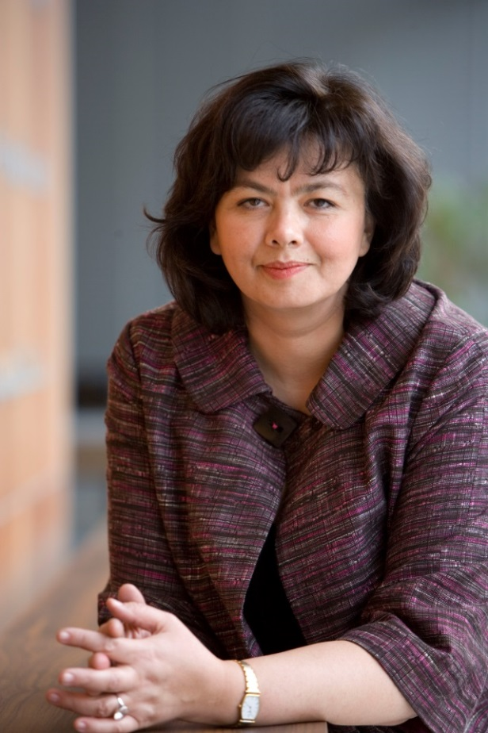
WHO is undergoing a major corporate transformation. Leadership and staff are jointly shaping an Organization that promotes health to create a better future for all, with a special focus on keeping the world safe and serving the vulnerable. In WHO Europe, the vision proposed by Dr Menabde is about aligning the organisation across levels, to strengthen partnerships and communication, and make innovation a driving force in all aspects of WHO’s work. Based on her experience as a health diplomat and WHO Representative to the UN, she will strategically apply approaches which emphasize WHO’s comparative advantages and guarantee the best outcomes. Under her leadership the WHO European Office will:
- Ensure the safety and security of the workplace, creating a harassment-free environment with zero tolerance for gender and other discrimination based on stereotypes;
- Invest in staff, as WHO’s unique asset, developing skills, offering career advancement and providing support mechanisms to help them embrace change, and ensure that talent is retained;
- Prioritize responsive and agile working modalities which deliver greater impact at country level; WHO’s communication and crisis response capabilities will be boosted; transparency and accountability will cut across all activities and offices;
- Champion scaling up knowledge, sharing best practices and promoting policy dialogue within and between countries; networks of designated Centres of Policy Excellence and Regional Experts will facilitate such exchange.
- Foster creativity with value-for-money policy options, with great potential for return on investment. This approach, in strict compliance with WHO rules and regulations, encompasses an enhanced engagement with the private sector to help develop new approaches for resource mobilization and management, and ensure access to innovative funding mechanisms.
- Promote inclusive, transparent and impactful partnerships with the European Union, G7, G20, the African Union, OECD, ASEAN and other regional and global players, to shape a shared, value based global health agenda and enhance the political impetus for health.

About Dr Nata Menabde, MSc, PhD
Country level achievements
- India became polio-free and eliminated yaws and maternal and neonatal tetanus during Dr Menabde’s tenure as leader of WHO India team. WHO South East Asia Region, including India, was certified as polio-free in 2014.
- Facilitated effective WHO collaboration with the government and private sector which resulted in prequalification of large number of medicinal products manufactured in India, bringing their number on WHO prequalification list to 350.
- Led WHO’s evidence-based multisectoral advocacy efforts that secured major progress in implementing the Framework Convention for Tobacco Control (FCTC), such as increase in taxes on tobacco products across India
- Ensured WHO normative support to the adoption of the Clinical Establishment Act, as well as the Mental Health and Disability Act, by the Parliament of India.
- Coordinated humanitarian assistance operations for refugees and displaced people in Georgia in times of crises and poverty.

With an exemplary track record of over 30 years of experience (with more than half in the European region) in regional and global health, health diplomacy and health systems, Dr Nata Menabde has shown unwavering commitment to the goal of Health for All and the values of the World Health Organization.

As Executive Director of the WHO Office at the United Nations in New York, she leads WHO’s engagement with the United Nations system and a broad range of stakeholders to anchor health in the 2030 Agenda for Sustainable Development. Prior to her current position, she was Head of Mission and WHO Representative to India, leading a large team with thousands of dedicated professionals in over 250 offices across the country. Most notably, her tenure saw one of the biggest achievements in public health: a polio-free India.

As Deputy Regional Director at the WHO Regional Office for Europe (2006-2010) she successfully led the Region’s work on strengthening health systems, which culminated in the development and adoption of the European Tallinn Charter: Health Systems for Health and Wealth, a decade ago. During this period she was also in charge of WHO’s extensive operations in 35 European countries, including emergency response and post-conflict recovery and rehabilitation. In this capacity, she successfully partnered the Council of Europe, the European Union, the European Commission, UNICEF, the World Bank, OECD, Global Fund, the European Investment Bank, among other key WHO’s partners.

Professionally, her accomplishments expand from spearheading effective humanitarian operations and modern pharmaceutical regulations in Georgia, to greater efficiency of WHO Country Offices and upgraded institutional service to WHO Member States, as also engaging with the UN system, diplomatic missions, and the major global development institutions.

A Georgian national, Dr Menabde is an inspirational speaker. She is fluent both in English and Russian. Having lived, trained, and worked in diverse settings, at country, regional and global levels, she can foster the European Member States’ full achievement of the health related Sustainable Development Goals by 2030, and facilitate and showcase Europe’s increasing contribution to global health.

A few notable achievements
Awards received
- Highest national award by the President – Zaza Panaskerteli gold medal for outstanding contribution to health development in Georgia, in 1977.
- Award of Merit from the Indian Medical Association for excellent contributions to the medical profession, in 2014.
- Woman Ambassadors Award for leadership by the NGO Committee on the Status of Women at the UN, in 2018.
- Mental Health Award for Excellence by the NGO Committee on Mental Health at the UN for outstanding leadership and advocacy, advancing significant progress in health care and mental health globally, in 2018.

Regional
- As the Deputy Regional Director at the WHO Regional Office for Europe, provided intellectual leadership and ensured successful outcome of the visionary WHO European Ministerial conference on Health Systems in 2008 resulting in adoption of a path breaking Tallinn Charter: Health Systems for Health and Wealth.
- Chaired WHO European Emergency Steering Committee, and led adequate response to emergencies and disasters, including the global response to pandemic influenza in Europe
- Ensured sustainable progress in implementing WHO European country strategy and championed horizontal integration of health systems and public health.
- Ensured WHO support to South East European Health Network set up to promote peace, reconciliation and cross-border health development, culminating in signing The Skopje Pledge as a cornerstone political agreement for cooperation and action on health.
- Provided strategic leadership and managerial support as the hosting partner, to work of the European Observatory on Health Systems and Policies
- Coordinated successful outcome of WHO European Regional Committees and other sessions of Governing bodies.
Global
- As the Executive Director of the WHO Office at the United Nations in New York, coordinated WHO’s political advocacy in support of the UN General Assembly (UNGA) 2015 and 2016 “Global health and foreign policy” resolutions acknowledging WHO leadership in global public health.
- Led and coordinated WHO efforts in preparation and New York based intergovernmental diplomatic negotiations for UNGA High Level meetings on antimicrobial resistance, noncommunicable diseases, and tuberculosis; leading to adoption of UNGA resolutions in 2016 and 2018.
- Ensured WHO’s strategic engagement with UN Development System Reform in New York, in alignment with WHO transformation.
- Mobilized political and diplomatic support in New York to Director General’s efforts related to UN Security Council resolutions on Ebola outbreak response and on attacks on healthcare facilities.
- Promoted India's contribution to global health by leading WHO efforts to ensure successful outcome of international assessment of the Indian Drug Regulatory Authority on vaccines, which ensured continued supply of India-manufactured generic medicines and vaccines to more than 150 countries.

